

***Adding the MI-MORT Mobile link to your***

***Mobile Device***

MI-MORT would like to introduce our Mobile Responsive Website Design.  Download our mobile Icon to your mobile device by following the following simple instructions.

1. Visit our website at your desktop or while on the go by having our Mobile Icon to your Apple or Android mobile device.

4. Add

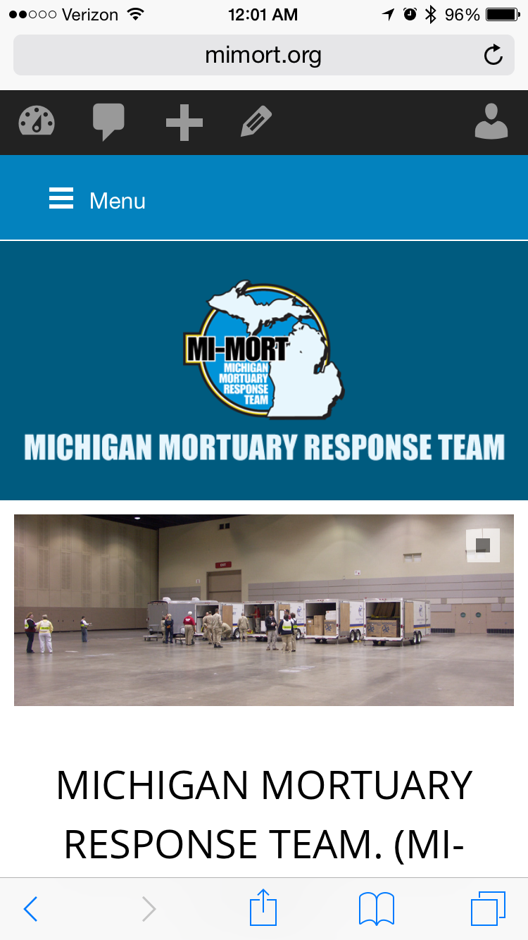 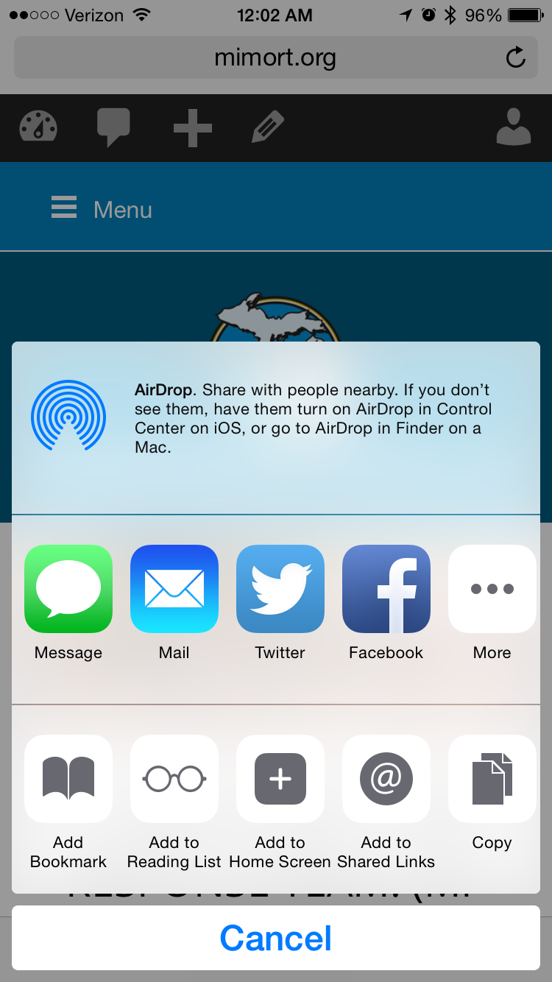 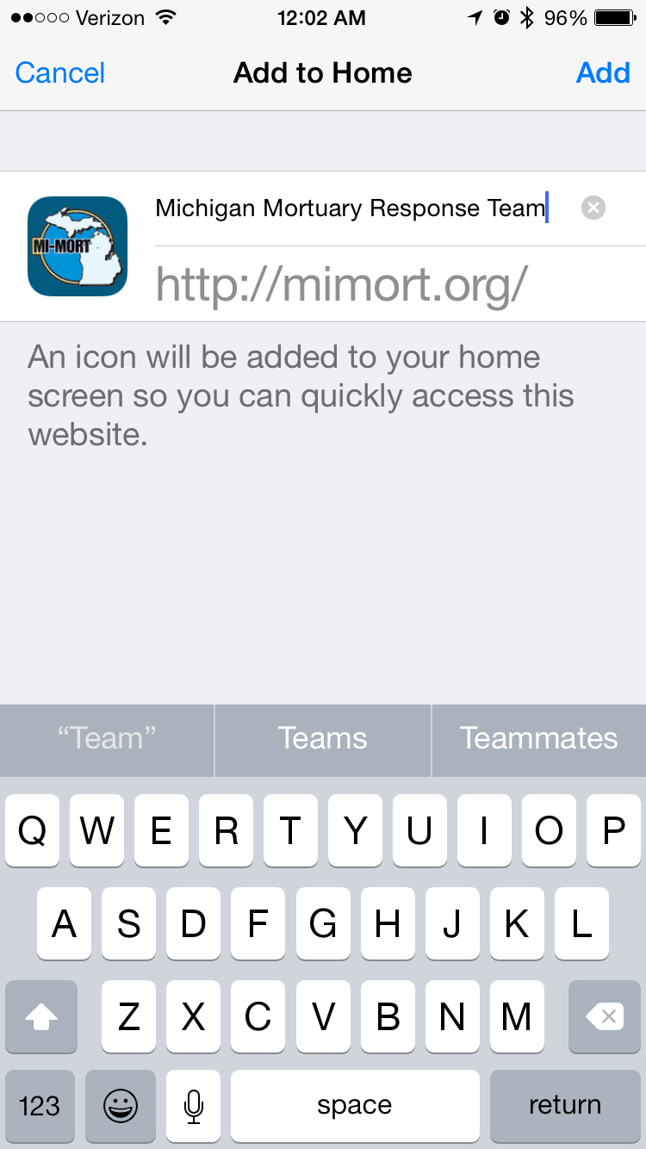 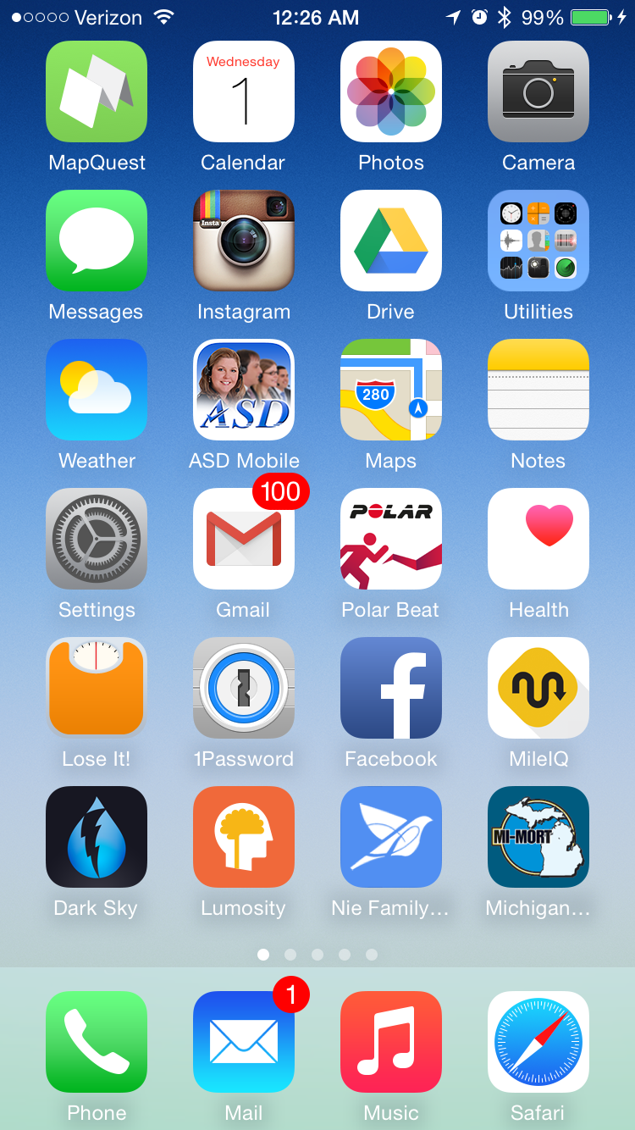

3.Then choose “Add to Home Screen”.   The icon will automatically be placed on your home screen.

2.Simply select the Share icon on your mobile device and the mobile icon will appear,

5. Done